**React Final Project -** [Mark Momot](https://medium.com/@markmomot03?source=post_page-----864e787b6dc5--------------------------------) Jan 15, 2022

So, what exactly is React?

If you know JavaScript, you’d know what a hassle it can be to manipulate the DOM. You have to create an element, add content to that element, grab the element you want to add that content to, and append the new element as a child to the part of the page where you want that new element to go to.

What happens when you have a lot of elements you want to add? Well, it becomes pretty tedious and repetitive.

Imagine being able to just write some simple HTML, and add it to the page with all the benefits of things you can do with JavaScript. Well, that’s where React comes in.

In React, you create files called components. You add each component to the DOM by rendering them, and all you have to do in each component is return what looks to be basic HTML, and React does all the work of creating an element, adding the information, and adding that element to the DOM behind the scenes.

Best of all, React automatically updates the webpage without having to reload the page.

I’ve been working in React for a little over a month now, and it has saved me a lot of time.

Building this website I built for my final project of phase 2 of Flatiron’s software engineering boot camp went a lot quicker than it would have with ordinary JavaScript.

React also allows you to create custom URLs for each part of your webpage. It allows you to create a website with multiple pages, with only one HTML file. This results in it being much more efficient.

There is a tool that you can import that’s called Browser Router. What this does is it looks at the URL that is currently typed in, and whichever “path” that URL matches, it loads that page.

You could manually type in the URL and you would get to that page, and in my code above, if you tried to type in a URL that does not exist, it would display a page that says “404 NOT FOUND.”

However, I needed a way for the user to be able to easily navigate the webpage without having to know the exact URL of where they wanted to go. This is where a NavLink comes in handy.

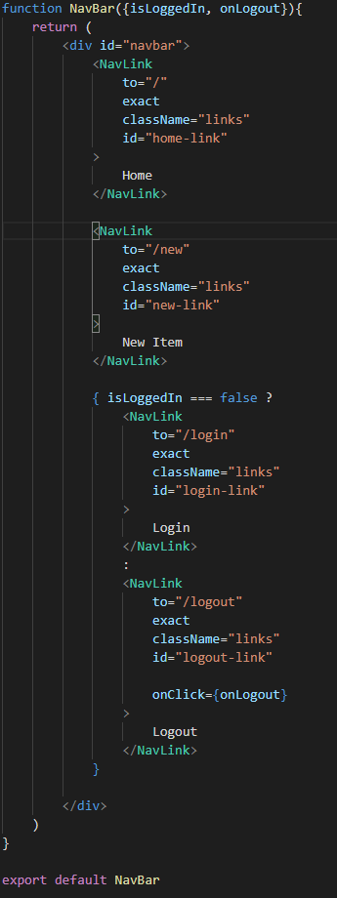

This creates a bar at the top of my webpage with quick access to links to navigate through the webpage. This is also an example of a full component in React and how it looks.

Also, whenever you update part of your application, it only refreshes that specific part of the application, instead of having to reload the entire page, which can start to take a while if you have 100s of HTML files to load.

This helps React gain it’s efficiency.

To summarize, React is an open source language based on JavaScript that web developers can use to create multipage applications quickly and easily.

Each page of the application can be split into components, and the components can also be split into smaller components to help parent components with their functionality.

It is more efficient than using separate HTML files for each page of the website, and also has benefits like being able to use JavaScript to handle the functionality of each page separately, or together.